Adding a Paradigm in Tabroom
July 2016 Edition

- Create a tabroom account for yourself if you haven’t already.
- Click on your email address at the top of the page.
- Look for the Judging section on the right. It looks like this: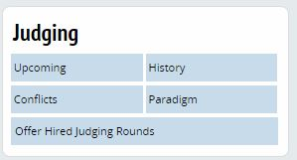
- Click on Paradigm.
- Type or copy and paste your paradigm here and click on Save Paradigm when you are finished. That’s it.
- *Advanced users can insert a hyperlink to another online source for their paradigm. If you choose this option, check it to make sure it works.

